

“An African environment appealing to a diverse crowd”

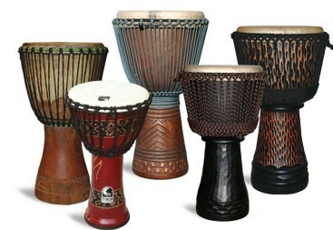



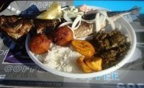

## **Elikia Restaurant**

# Authentic African Cuisine, Music and Entertainment

E-mail:

[**www.elikiarestaurant.com**](http://www.elikiarestaurant.com)



Come experience authentic African Cuisine and Culture: Unique-Authentic-Diverse-Classy-Relaxed-Fun

Hours: Wednesday – Saturday 5PM – 2 AM

Thursday – Reggae Night 10PM – 2AM

Power Hours: 8-10 PM - $2.50 Domestics and Wells, Special Du Jour

African Food & Diverse Music WIFI available

-Authentic-Diverse-Classy-Relaxed-F

### Elikia Restaurant

118 2nd Street, Suite C.

Coralville, IA 52241

Phone: 319-887-0966

Fax: 319-335-4489